📘 Chapter 11 – 2D Transforms in CSS: Ghumao, Hilaao, Badhao! 🌀

🧾 What is CSS Transform?
transform: ek CSS property hai jo element ko modify/move karti hai — without changing its actual position in HTML.
Matlab element wahi rehta hai, lekin rotate, zoom, move, tilt sab ho sakta hai 😎
2D me sirf X aur Y axis ka use hota hai.

✨ 2D Transform Properties:
Property | Kaam kya karta hai
translate(x, y) | Element ko move karta hai
rotate(deg) | Element ko ghumata hai (deg me)
scale(x, y) | Size badhata/ghataata hai
skew(x, y) | Element ko tilt karta hai (angle se)
matrix() | Sab kuch ek hi function me mix karta hai (advanced)

🔀 1. Translate – Move Karna
<div style="transform: translate(50px, 20px);">
👉 Yeh box 50px right aur 20px niche gaya
</div>
🧠 Positive value → right/bottom
Negative value → left/top

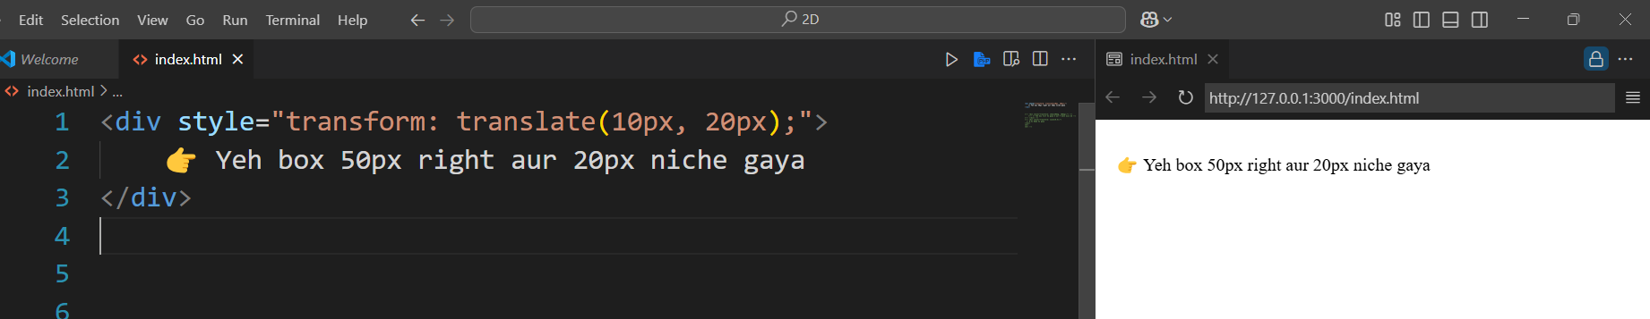

🔄 2. Rotate – Ghuma Dena
<div style="transform: rotate(45deg);">
🔄 Yeh box 45° ghoom gaya
</div>
🧠 -45deg doge to ulta ghoomega (anti-clockwise)
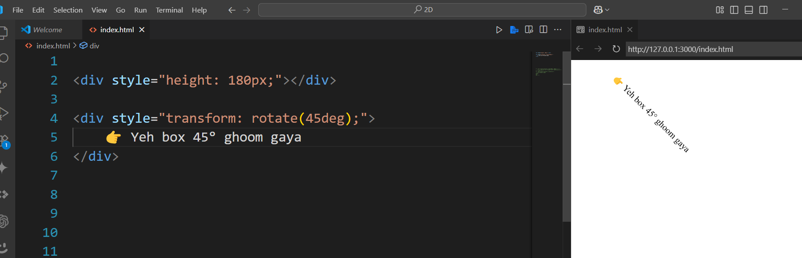

🔍 3. Scale – Zoom In/Out
<div style="transform: scale(1.5);">
🔍 1.5x Bada ho gaya
</div>
🧠 scale(2) = 2x bada
scale(0.5) = 50% chhota

s
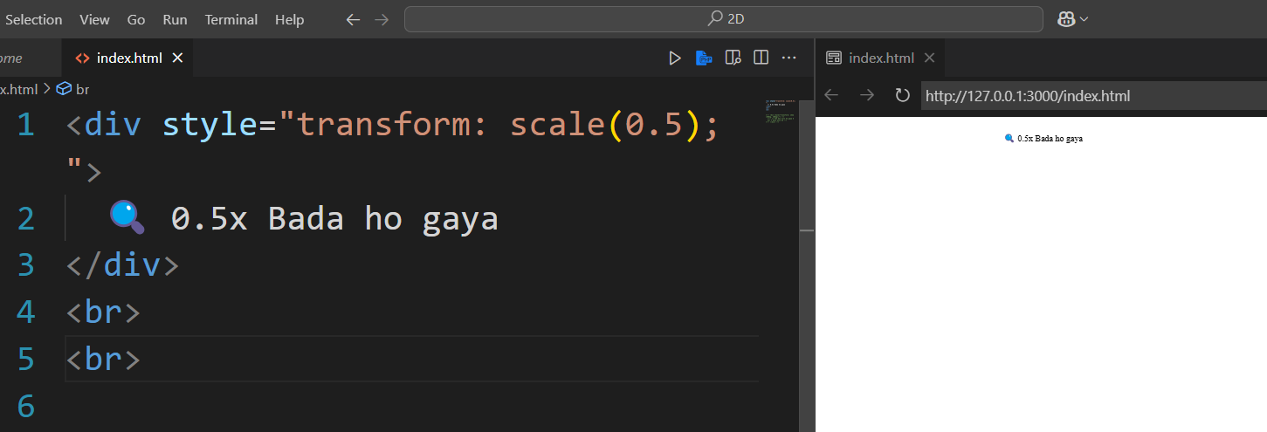

💫 4. Skew – Tilt Karna
<div style="transform: skew(20deg, 10deg);">
💫 Yeh box tilt ho gaya X aur Y dono axis me
</div>
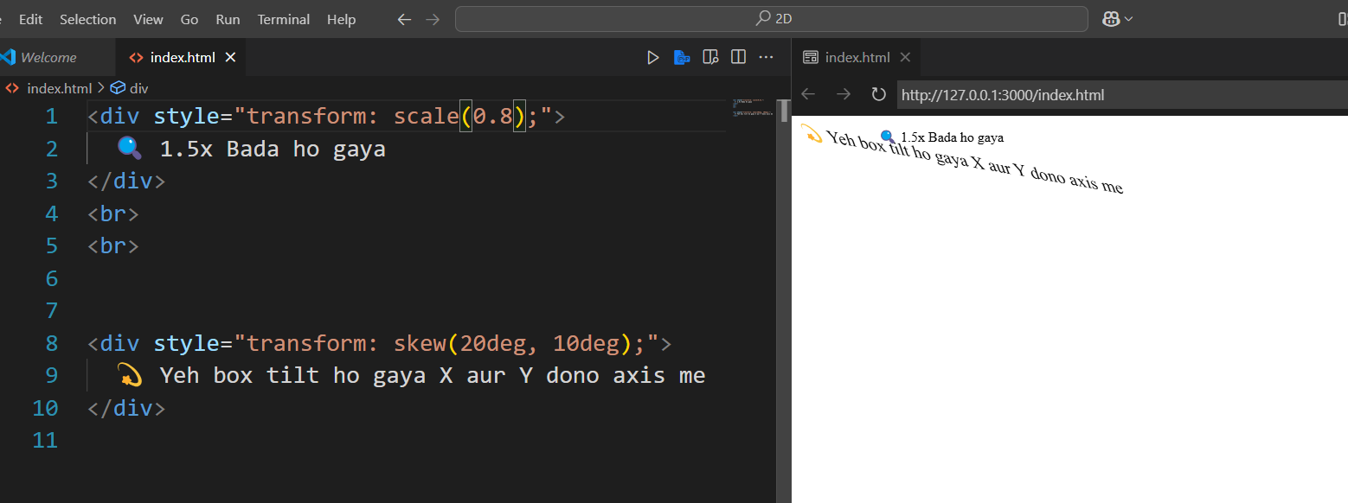

🔬 5. Matrix – Advance Combo
Rarely used – mix of all above in ek hi line.
transform: matrix(scaleX, skewY, skewX, scaleY, translateX, translateY);
🔧 Advanced devs ke liye hai – abhi ke liye chhodo 😅
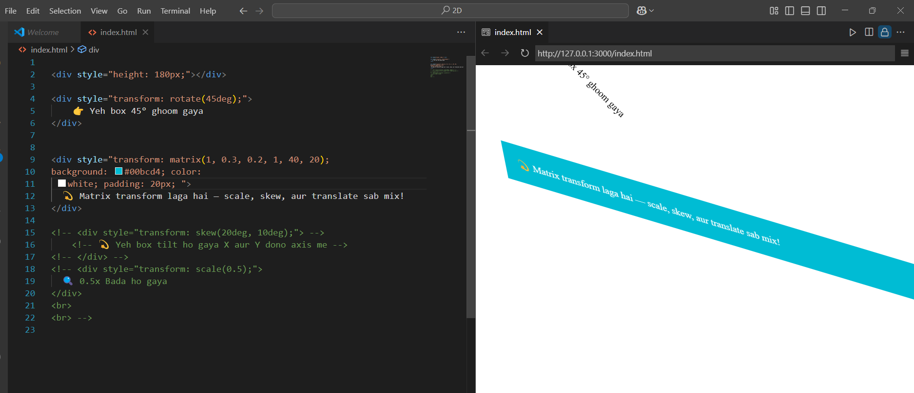

🖼️ Example with Hover Effect:
<style>
.hover-box {
width: 100px;
height: 100px;
background: tomato;
transition: 0.3s;
}

.hover-box:hover {
transform: rotate(15deg) scale(1.2);
}
</style>

<div class="hover-box">🌀 Hover Me</div>
🧠 Hover pe zoom bhi hoga, ghoomega bhi – mast stylish!

📐 Notes:
- transform: CSS me inline bhi likh sakte ho ya class me bhi
- Combine bhi kar sakte ho → transform: rotate(45deg) scale(1.5);
- Use transition: to make it smooth

📱 Summary:
- translate(x, y) → Move karo
- rotate(deg) → Ghumao
- scale(x, y) → Zoom in/out
- skew(x, y) → Tilt karo
- Combine bhi kar sakte ho ek line me
- Use transition: for animation effect

